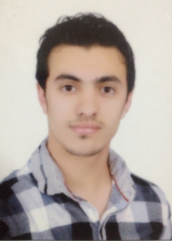
Osama Moheb Abd Elaleem
Aga , Mansoura , DK , Egypt
Phone: 01280110867
E-Mail: Osama_moheb3@hotmail.com

Objective:

Utilizing and enhancing my skills and qualifications through a big organization which encourages continuous education and development of its employees, and through which I can interact and work efficiently in a dynamic environment to prove myself .
Education:

Bachelor of Commerce and Business Administration ( 2013 ) .

Major: accounting department .

Grade: good .

Extra Courses:

Certificate in ICDL (International Computer Driving License ( .

Certificate in English Course From Mansoura University .

Certificate in Accountant’s Preparation Course (Very Good) From Mansoura University .

Certificate in Peachtree Course (Very Good) From Mansoura University .

Certificate in Oracle Financial Program in Mansoura University .

Certificate in Amadeus Course .
Skills:
- Languages:

Mother Language: Arabic .

Second Language: English .
- Computer:

Good command of Microsoft office .

Good writing and dealing with the Word program .

Good at using computer office program(internet-Excel-Power Point-Word-Windows )
- Personal:

Work under stress and Pressure, Inactive, Organizational skills and problem solver .

Object oriented, self-motivated, quick learner, and hard worker .

Team leader capable of developing a clear vision and strategy .

A member of the Association of Accountants .
Personal Information:

Date of Birth: august 3, 1991 .

Marital Status: Single .

Nationality: Egyptian .

Military Status: Finished .

