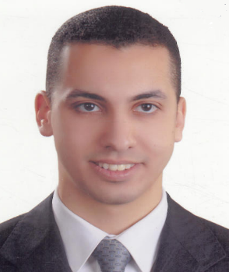
Akram Mohamed Mohamed Ahmed Wahba

Address: Dubai, UAE.

Mobile: 504808841

Egyptian, 4 June 1984 – Married.

E-mail: Akram.wahba@gmail.com

OBJECTIVE

Looking forward to building a great career in a reputable company to obtain a challenging and responsible position within the Sales & Marketing field where I can use my skills and knowledge to achieve the overall success of the organization.

Work Experience

April 2015 - Present

Vodafone, Egypt (www.vodafone.com.eg)
Title: Sales Executive, B2B Channel.

Duties & Responsibilities

- Managing D2D suppliers to meet the company requirements and achieve channel targeted contribution margin, MS and RS.
- Maintain and support productive, professional relationships with vans suppliers.
- Arrange sales team trainings required to run their day-to-day job.

September 2010 – March 2015

Vodafone, Egypt (www.vodafone.com.eg)
Title: Sales Executive, Indirect Sales-Dealers Channel.

Duties & Responsibilities

- Educate dealers and sales force teams how to sale VF products effectively , maintain dealers satisfaction , margins based one quality ,and encourage retail expansion
- Switching the key dealers from competitions, to join VF exclusivity.
- Monitoring the dealers' performance and encourage them to achieve/exceed their targets based in quality in order to be promoted to a higher class.
- Expand VF active dealer vertically & horizontally.

May 2009 – August 2010

Vodafone, Egypt (www.vodafone.com.eg)
Title: Sales Representative, Direct Sales-TKA Channel.

Duties & Responsibilities

- Selling Vodafone all products and services, achieve monthly target.
- Handling any inquiry or customer complaint.
- Inventory management and team management.

May 2009 – August 2010

El Kayar Trading, Engineering and Agencies (www.kayer.com)
Title: Accountant.

Duties & Responsibilities

- Perform most of the same functions of an accountant for any other type of business, account receivable, cash flow, inventory….etc.
- Prepare financial statements, balance sheet and income statement.

Education & Courses

- Bachelor of Commerce, Accounting - Alexandria University-Egypt.
Graduation year: 2007, Overall grade: Good
- Executive Master of Business Administration 2013-2016 from Alexandria University.
- Smart Selling Skills course.
- Accounting course in Egyptian Society for Charted Accounting.
- Reach and Conquer from Consumer Sales Academy-Vodafone.

SOFT SKILLS

- Excellent communication and negotiation skills.
- Self-motivated and ambitious.
- Ability to work in groups as individually according to job requirements.
- Ability to deliver under strict deadlines and excellent trouble shooting skills.

Interests References

- Reading. Sofian Abd El Motaleb : +201005009202
- Walking. Kareem Sallam : +201001900010

