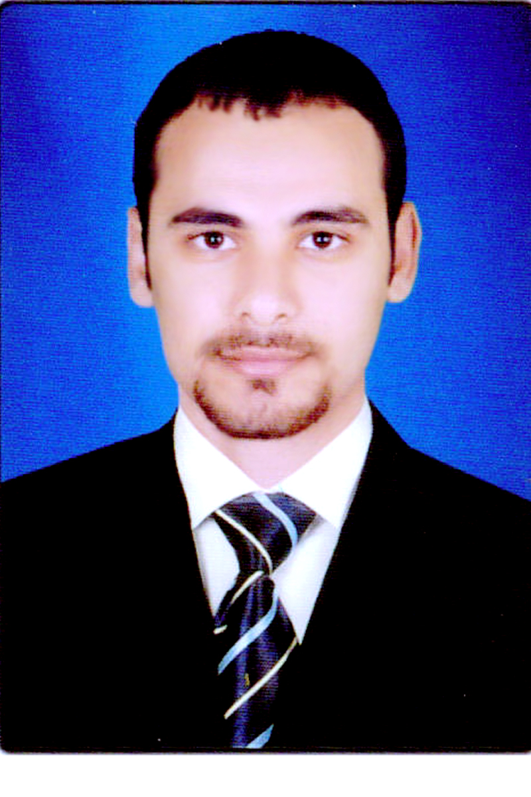Anas Ibrahim Awad Sayed,ahmed
Quesna – Monofia - Egypt
E-mail : anasibrahim1020@gmail.com
Phone : 01012543344

Personal data:
Date of Birth: 13May-1990
Gender: Male
Marital status : single
Nationality: Egyptian
Military Service: finished

Academic Education:
Al-Azhar University - Faculty of Science ( 2008 – 2012)
Specialization : Zoology
BSc in Zoology
Grade: Good (72.8 %)

Experience:
* Medical rep. at macro group for cosmoceutical industry from 1/2015 to 9/2015 .
* Medical rep. at Egyptian group for pharmaceutical industries from 10/2015 to now .

Skills:
Language: * Arabic language : Mother tongue
* English : Good
Computer: * Knowledge and experience of Windows 7, MS Word, MS Access,
using email and the Internet.

